**PDE4431 – Robot Manipulation**

Coursework – 01

Middlesex University Dubai

**N. G. Jayashanka Anushan,**

**MISIS – M01037028**

**MSc in Robotics (2024 / 2025 Year-01)**

# Table of Contents

Table of Contents 2

1). Introduction ** Change the robot type 3

2). Task Explanation 3

3). Achieve the task ***How I do it 4

3.1). Setting up the tools 4

3.2). Setting up the frame 4

3.3). Initialize the coordinates 4

4). Task preparation ***Performance sheet 5

5). Pre-Preparation works 5

6). Task Demonstration ***Video 5

7). Conclusion 5

***List of Figures***

Figure 1 Epson RC 7.4.3 Programming Software Source:(Author Developed) 4

***List of Tables***

*No table of figures entries found.*

# Introduction ** Change the robot type

PDE4430 – Robot Manipulation module will be taught to use and program state-of-the-art robot arms and end effectors, such as those employed in car production lines, CNC machines, medical research, pick and place operations. Such machines are generally mounted in fixed positions and can move with speed or with load-carrying capability and precision. Programming an industrial robot is a challenge to bring the real-world purpose to real experience.

In this coursework we have been assigned to use one of following robots to complete the task as per the facilities provided by the university.

* Epson VT6 – (6 Axis)
* Epson T6 – (Scara)

<<Add images of Scara and VT6 Robots>>

# Task Explanation

Task has been declared to move / draw the robot on given path. Path programming concept to be applied to the coursework aligned with tool setting and frame setting (if required). Randomly paper has been selected by the lecture and distributed to the student for implement the received design.

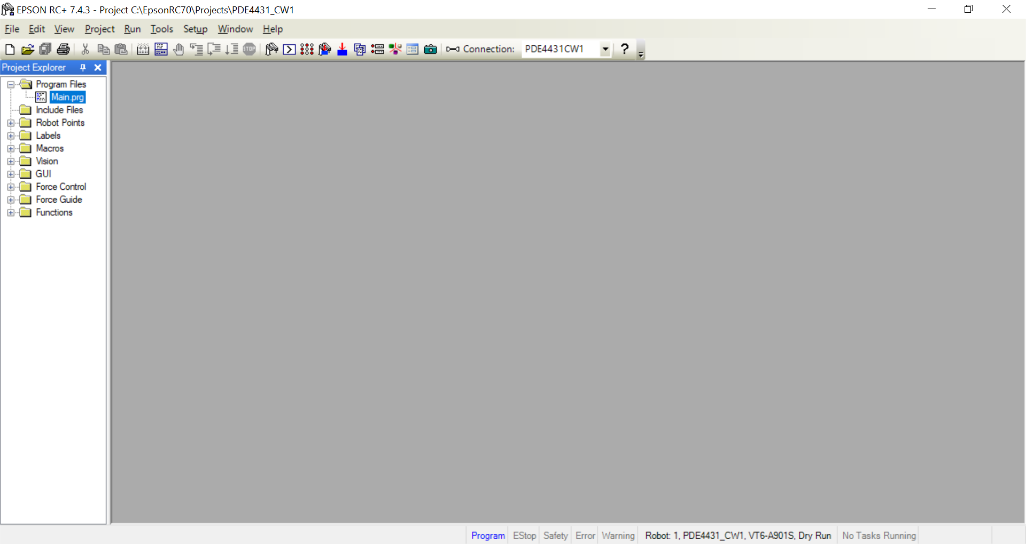

Figure 1 Epson RC 7.4.3 Programming Software Source:(Author Developed)

# Achieve the task ***How I do it

Distributed papers contained printed designs of three letters and a frame as follows to do the path programming.

<<<<Sample IMG of given task>>>>

Required area has been divided into four functions and each function called one after another to complete the task. Each letter assigned as a function and frame of the letters has been a separate function.

## Setting up the tools

## Setting up the frame

## Initialize the coordinates

# Task preparation ***Performance sheet

# Pre-Preparation works

# Task Demonstration ***Video

Youtube link required

# Conclusion